Dam Flow Routing in COMPASS
COMPASS allocates flows in a dam between powerhouses and spill using the requested spill and minimum flows (for each powerhouse). This document describes the algorithm and the input parameters required to use it. An example with a graph is provided at the end in order to clearly explain the algorithm.

Parameters
Spill schedules are used to determine the fraction of flow that is spilled as requested by the user. Note that spill may be more or less than requested in extreme cases (see the algorithm description below for more information). There is also a spill capacity (spill_cap) which should not be exceeded (otherwise a warning is printed out).
Each powerhouse has a minimum flow required which is described by the flow_min token which is specified in KCFS. This value should correspond to the minimum amount of flow required by the powerhouse in order to function. Here is an example of its use:
dam Lower_Granite_Dam
flow_min 10
end dam (Lower_Granite_Dam)
As expected, this sets the minimum flow through the main powerhouse of Lower Granite to 10 KCFS.

Algorithm
Flow is allocated in the following order:
- Start with the priority powerhouse
- Fill to flow_min (otherwise a warning is emitted)
- Spill up to planned spill fraction
- Add flow to this powerhouse until flow_min for next powerhouse
- Turn on the next powerhouse with flow_min
- Fill first phouse up to hydraulic capacity
- Fill second phouse to hydraulic capacity
- Spill until spill capacity is reached
- Spill remaining and emit warning of exceeding the spill cap

Example
The following graph shows how flow is allocated as flow is increased. A description of the line segments in the graph and their meaning is given after the graph.
The first powerhouse (PH1) has a minimum flow of 5 KCFS and a hydraulic capacity of 10 KCFS. The second powerhouse (PH2) has a minimum flow of 4 KCFS and a hydraulic capacity of 7 KCFS. The requested spill fraction is 0.2 of total flow.
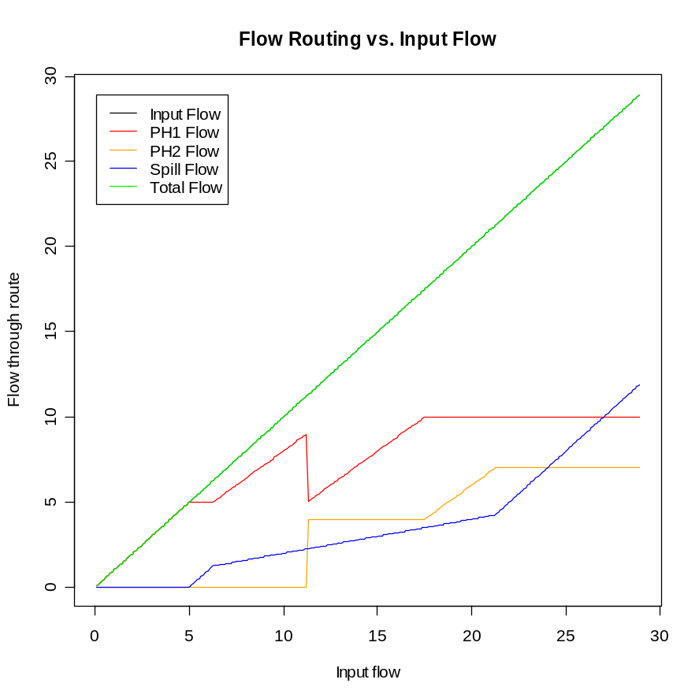
The blue line represents spill. Before 5 KCFS, there is not enough flow for the first powerhouse and so there is no spill. After 5 KCFS, the flow is spilled until the spill fraction of 0.2 is reached. Spill remains at 0.2 of total flow until around 22 KCFS, at which point the flow exceeds the hydraulic capacity of both powerhouses and all the remaining flow is spilled (note that this may end up exceeding the spill capacity).
The red line represents the first powerhouse (PH1) and the orange line represents the second powerhouse (PH2). Note that the second powerhouse is only turned on once its minimum flow is available (about 11 KCFS in this graph) at which point excess flow from the first powerhouse is diverted to the second. Once the first powerhouse is full to hydraulic capacity (around 17 KCFS in the graph), the second powerhouse is filled to hydraulic capacity.

